|  |  |
| --- | --- |
| **Logo_FPT_University_doc** | **MINISTRY OF EDUCATION AND TRAINING** |

|  |
| --- |
| **FPT UNIVERSITY** |
| Capstone Project Document |
| Personal Task Management |
|  |
| |  |  | | --- | --- | | **Antares** | | | **Group Members** | Lê Hoàng Hưng 01011  Trương Trung Nghĩa 01300  Lê Xuân Nghĩa 01322  Vũ Thanh Bình 00919  Trần Thái Sơn 00845 | | **Supervisor** | Lã Ngọc Quang | | **Ext Supervisor** |  | | **Capstone Project code** | eSec | |
|  |

- Hanoi, 9/2012 -

|  |
| --- |
|  |

Contents

[Contents 2](#_Toc335349456)

[PART I: INTRODUCTION 3](#_Toc335349457)

[I. Introduction 3](#_Toc335349458)

[**1.** **Project Information** 3](#_Toc335349459)

[**2.** **Purposes** 3](#_Toc335349460)

[**3.** **The People** 3](#_Toc335349461)

[**4.** **Background** 4](#_Toc335349462)

[II. Literature Review 4](#_Toc335349463)

[III. Idea Proposal 8](#_Toc335349464)

[**1.** **Problem** 8](#_Toc335349465)

[**2.** **Solution** 8](#_Toc335349466)

[2.1 **Advantages** 8](#_Toc335349467)

[2.2 **Disadvantages** 9](#_Toc335349468)

[2.3 **Global picture** 10](#_Toc335349469)

[IV. References 10](#_Toc335349470)

# PART I: INTRODUCTION

# Introduction

## **Project Information**

* Project name: Personal Task Manager.
* Project code: eSec.
* Product type: Windows Store Application (Windows 8).
* Timeline: from Sep 2012 to Dec 2012.

## **Purposes**

This project is registered and implemented as the capstone project for the team members. The first purpose is to fulfill the studying program of FPT University. The second purpose is to create a complete product for going live if the project is appreciated by the capstone project’s council.

## **The People**

Supervisors:

|  |  |  |  |  |
| --- | --- | --- | --- | --- |
|  | **Full name** | **Phone** | **E-Mail** | **Title** |
| Supervisor 1 | Lã Ngọc Quang | 091.231.8493 | [quangln@fpt.edu.vn](mailto:quangln@fpt.edu.vn) | Lecturer |

Team members:

|  |  |  |  |  |  |
| --- | --- | --- | --- | --- | --- |
|  | **Full name** | **Roll no** | **Phone** | **E-mail** | **Role** |
| 1 | Lê Hoàng Hưng | 01011 | 01687764190 | [hunglh01011@fpt.edu.vn](mailto:hunglh01011@fpt.edu.vn) | PM |
| 2 | Trương Trung Nghĩa | 01300 | 01649601242 | [nghiatt01300@fpt.edu.vn](mailto:nghiatt01300@fpt.edu.vn) | Developer |
| 3 | Trần Thái Sơn | 00845 | 01686712217 | [sontt00845@fpt.edu.vn](mailto:sontt00845@fpt.edu.vn) | Tester |
| 4 | Vũ Thanh Bình | 00919 | 01656056389 | [binhvt00919@fpt.edu.vn](mailto:binhvt00919@fpt.edu.vn) | Developer |
| 5 | Lê Xuân Nghĩa | 01322 | 0904380699 | [nghialx01322@fpt.edu.vn](mailto:nghialx01322@fpt.edu.vn) | Designer |

## **Background**

How to work more effectively? Nowadays, human beings are unexplainably busy: works and other responsibly take most of their time. In the modern competitive life, people must treasure every second, every minute. However, some people waste their time on some unnecessary things, so their lives become more tired and more stressed.

The important thing in modern life is what to do in a day, and what should you spend your time on? Normally, we all have daily plans, but a lot of people do not follow those plans but do thing arbitrarily, so time-management becomes difficult. Besides, some are too busy with businesses and forget to logically arranging them. The time is yours and it's you who have to decide how to use it. Some specialists pointed out that: every person wastes about 2 hours per day.

Together with the fast paced life rhythm is the light speed development of portable devices, and especially tablet's explosive expansion. Tablet is becoming more and more attached to daily life and it excellently supports daily works of businessmen, pupils, students... all over the world. So, the birth of an application which helps manage works and schedule-planning in an optimal way is very necessary.

# Literature Review

Nowadays, there are few applications which help us to manage schedule. Here are the details:

* + - 1. **Google Calendar** (www.**google**.com/**calendar**)

**Google Calendar** is a free time-management [web application](http://en.wikipedia.org/wiki/Web_application) offered by [Google](http://en.wikipedia.org/wiki/Google). It became available on April 13, 2006, and exited the [beta](http://en.wikipedia.org/wiki/Development_stage#Beta) stage in July 2009. Users are required to have a [Google Account](http://en.wikipedia.org/wiki/Google_Account) in order to use the software. There are the main features:

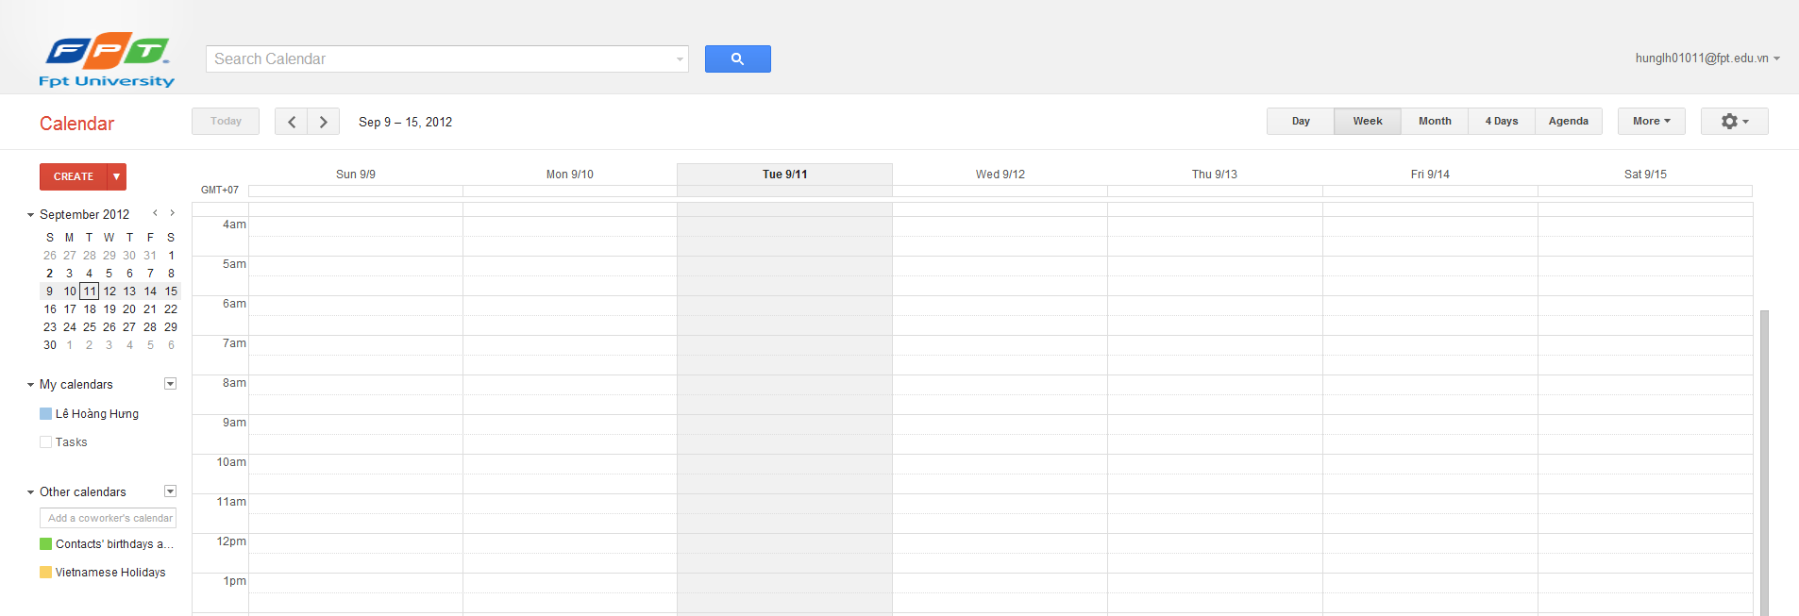

* [**Interface**](http://en.wikipedia.org/wiki/Google_Calendar#Interface)

The [Ajax](http://en.wikipedia.org/wiki/Ajax_(programming))-driven interface enables users to view, add, and [drag-and-drop](http://en.wikipedia.org/wiki/Drag-and-drop) events from one date to another without reloading the page. It supports view modes such as weekly, monthly, and agenda.

* [**Content access**](http://en.wikipedia.org/wiki/Google_Calendar#Content_access)

Events are stored online; consequently, the calendar can be viewed from any location that has Internet access. For users who might experience a [hard drive](http://en.wikipedia.org/wiki/Hard_drive) failure, it also means that no data is lost. Multiple calendars can be added and shared, allowing various levels of permissions for the users.

* [**Sharing calendars**](http://en.wikipedia.org/wiki/Google_Calendar#Sharing_calendars)

Google Calendar allows multiple calendars to be created and shown in the same view. Each can be shared, either read-only or with full edit control, and either with specified people or with everyone (public calendars). In February 2009, Google discontinued the option of searching for public calendars from the search field by removing the "Search Public Events" button.

* [**Device synchronization**](http://en.wikipedia.org/wiki/Google_Calendar#Device_synchronization)

Currently, Google Calendar can use Google Sync to synchronize with many mobile devices. Event reminders can be sent via email, as well as via [SMS](http://en.wikipedia.org/wiki/SMS) to [mobile phone s](http://en.wikipedia.org/wiki/Mobile_phones)in more than eighty countries and regions.

* [**Google integration**](http://en.wikipedia.org/wiki/Google_Calendar#Google_integration)

Google Calendar is integrated with various other Google services:

* [Gmail](http://en.wikipedia.org/wiki/Gmail), Google's [webmail](http://en.wikipedia.org/wiki/Webmail) service. When an e-mail that contains trigger words (such as "meeting", or dates and times) arrives, an "add to calendar" button is automatically displayed alongside it.
* [iGoogle](http://en.wikipedia.org/wiki/IGoogle), the user-designed Google homepage, in which users can choose and organize content in the form of "gadgets". The calendar is shown as a module on your homepage. This "gadget" offers options to edit how the time is displayed, which day the week starts on, and a link to "Add Event".
* [Google Desktop](http://en.wikipedia.org/wiki/Google_Desktop), Google's [desktop search](http://en.wikipedia.org/wiki/Desktop_search) software for [Windows](http://en.wikipedia.org/wiki/Windows) or [Mac OS X](http://en.wikipedia.org/wiki/Mac_OS_X). The mini-calendar gadget allows you view your agenda without having to open your browser. You can place it on your desktop or leave it docked in the sidebar.
  + - 1. **Yahoo Calendar** (**calendar**.**yahoo**.com)

**Yahoo! Calendar** is a [Web](http://en.wikipedia.org/wiki/World_Wide_Web)-based [calendar](http://en.wikipedia.org/wiki/Calendaring_software) service from [Yahoo!](http://en.wikipedia.org/wiki/Yahoo!). While users are not required to have a Yahoo! Mail account, they are required to have a free Yahoo! ID in order to use the software. Yahoo! Calendar has the following features:

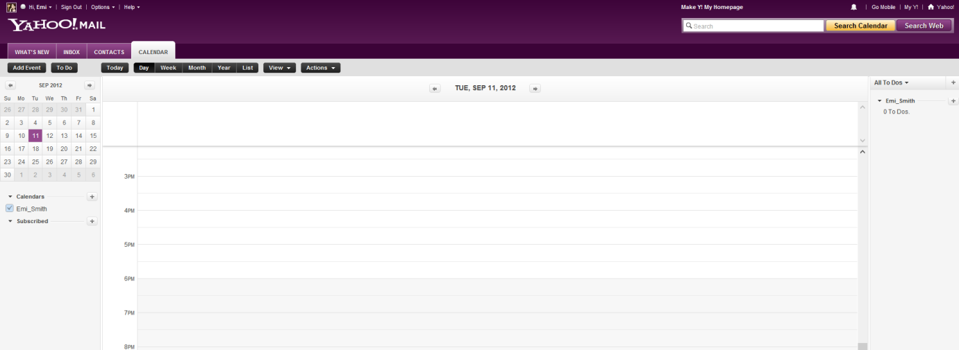

* 100 year calendar.
* Various alarm features which allow you to send messages to numerous sources including:
  + Email
  + Mobile Devices
  + [Yahoo! Messenger](http://en.wikipedia.org/wiki/Yahoo!_Messenger)
* The ability to [sync](http://en.wikipedia.org/wiki/Data_synchronization) your calendar with those of [Palm](http://en.wikipedia.org/wiki/Palm_(PDA)) devices and [Microsoft Office Outlook](http://en.wikipedia.org/wiki/Microsoft_Office_Outlook), [CalDAV](http://en.wikipedia.org/wiki/CalDAV), and some [SyncML](http://en.wikipedia.org/wiki/SyncML) enabled [cellphones](http://go.yahoo.com/next/devices_syncml).
* Sharing of schedules between users. The mechanism allows several different methods of sharing including publicly sharing your calendar, sharing your calendar with a specific [Yahoo! Group](http://en.wikipedia.org/wiki/Yahoo!_Groups), and sharing your calendar with a particular Yahoo! user.
* Automatically read, integrate, and republish public and personal events syndicated from [Eventful](http://en.wikipedia.org/wiki/Eventful), [Upcoming](http://en.wikipedia.org/wiki/Upcoming), [Evite](http://en.wikipedia.org/wiki/Evite), [Bookwhen](http://en.wikipedia.org/w/index.php?title=Bookwhen&action=edit&redlink=1), and other sites.

Events are stored online, so in the case of a user's hard drive failure, no data is lost. Calendar sharing is also available.

* + - 1. **Hotmail Calendar** (**calendar**.msn.com)

Hotmail Calendar (previously known as Windows Live Calendar and Windows Live Hotmail Calendar) is a time-management [web application](http://en.wikipedia.org/wiki/Web_application) by [Microsoft](http://en.wikipedia.org/wiki/Microsoft) as part of its [Windows Live](http://en.wikipedia.org/wiki/Windows_Live) services. It is integrated into [Hotmail](http://en.wikipedia.org/wiki/Hotmail), the way that MSN Calendar was integrated into the MSN Hotmail service.

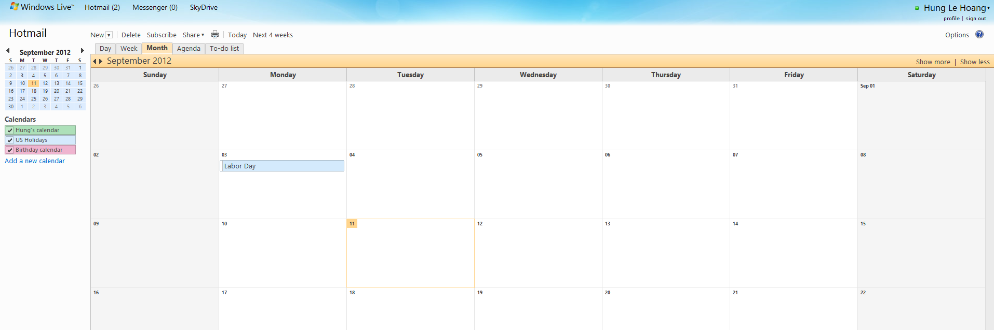

It features daily, weekly, monthly and agenda view modes. It also features a to-do list function for users to keep track of their tasks to be completed.

Hotmail Calendar events are stored online and can be viewed from any location. Multiple calendars can be created and shared, allowing different levels of permissions for each user. Users are able to share their Hotmail Calendar via three different methods:

* Private sharing - other users may sign-in with their [Microsoft account](http://en.wikipedia.org/wiki/Microsoft_account) and view, edit and/or delete calendar entries based on the invitation by the owner
* View-only link - other users may receive a view-only link to the calendar being shared, and be able to subscribe to the calendar via [RSS](http://en.wikipedia.org/wiki/RSS) or [Webcal](http://en.wikipedia.org/wiki/Webcal)
* Public sharing - other users may search and view the calendar on the web
* Reminders - users can set up to 6 reminders per event and can have them sent to [Messenger](http://en.wikipedia.org/wiki/Windows_Live_Messenger), their phone or an email address. They can also set default reminders for each calendar. On shared calendars, users can choose to get notified when another user edits an event.

[Windows Live Mail](http://en.wikipedia.org/wiki/Windows_Live_Mail) features a Calendar mode that allows automatic syncing with Hotmail Calendar when signed in with a Microsoft account.

# Idea Proposal

## **Problem**

Since almost the difficult was told in 4.Background, we can have the conclusion here:

* People manage task not effect. Need an application to control their task.
* This is the tablet era, should aim to that target. Windows 8 Modern UI (Metro) application is good place to start.

## **Solution**

We, who work in this project, will provide a new application can solve the problem above. This application has responsible to manage task of end user and give them the offer to change their daily life. With some simple action, they can easily manage their life as well as the task.

### 2.1 **Advantages**

**Timeline view:**

- General view about what users did, what they are doing or what will be done in the future

- Users will get to know whether or not they logically arranged their tasks in a specific period of time.

- Besides, the users will easily see their work-densities in a time period. Base on that, they can arrange their schedule in a more logical way.

**Modern UI Interface:**

- Easier observation of users' tasks.

- Images which are designed in Metro style make users feel more realistic when interacting with their schedule.

**Intelligent:**

As we can see, the existing products (Google Calendar, Yahoo Calendar, etc.) support users to manage their tasks with pre-defined time. This has some disadvantages, especially to some users who are businessmen. With their over-large quantities of works and some even don't have fixed time, businessmen become confused when they add their tasks to the schedule. So, we - the Personal Task Management development team - have decided to include in our product an exclusive function: smart arrangement. With our application, the users will not encounter confusing situations which they get a lot when they use other applications. What they only need to do is to define the task, as the arrangement part is done automatically by eSec in a second. The auto arrangement not only uses complex, mathematical algorithm, but also learns from the users themselves. You often go out in weekend, or go to the cinema each Saturday evening? eSec learns from your daily habits, and arranges your tasks in a way that make you feel very familiar and comfortable, which every other application is not capable of.

**Work offline:**

Because almost other application is web based app, end user can’t use the application when they do not have the internet connection. But eSec takes advantage to work offline with the cache file. You don’t have to afraid the connection any more.

### 2.2 **Disadvantages**

Since the application is developed in Windows 8 - Modern UI applications, it will limit the number of user to use this. The requirement for the end user machine is installed Windows 8 OS. While other application is web based app, mean that, they can use any OS.

### 2.3 **Global picture**

**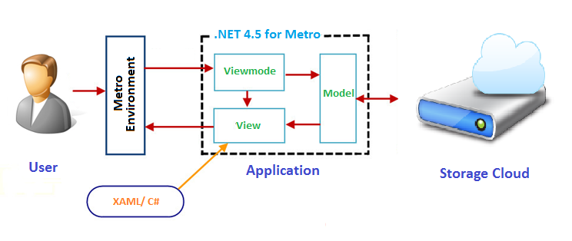**

# References

1. [http://en.wikipedia.org/wiki/](http://en.wikipedia.org/wiki/Vietnamese_cuisine)
2. <http://calendar.msn.com/>
3. <http://calendar.yahoo.com/>
4. <http://www.google.com/calendar>